Game Analysis Worksheet
Name of the game: A Hat in Time
Publisher: Gears for Breakfast (self-published on PC via Steam/Humble Bundle); console ports by Limited Run Games (PS4/Xbox One/Switch)
Date of Publication: October 5, 2017 (PC/Mac/Linux); October 5, 2018 (consoles); Seal the Deal DLC December 6, 2017
Operational Rules
Number of Players and Type of Interaction
1 player (single-player campaign);
local co-op 2 players (Seal the Deal DLC);
online party 4 players (Nyakuza Metro DLC);
Cooperative exploration/combat;
competitive racing in Time Rifts;
Race vs Brawl
Pure Race Pure Brawl
X
1 10
List of actions players can take in the game (Verbs of the game)
- Jump (single/double), ground pound (dive down), dash (sprint hat), dive (momentum boost)
- Switch/use hats (Sprint: dash; Brewing: bombs; Umbrella: attack/hookshot; Ice: slide/freeze; Dweller's: hide; Time Stop: pause time)
- Collect (Time Pieces, Pons, Yarn Balls)
- Attack (umbrella swing, bombs)
- Interact (NPCs, switches, puzzles)
- Craft hats (Yarn at stations)
- Equip badges (health/jumps/time stop)
- Race (Time Rifts), boss fight, explore (100% acts).

Goal of the Game
Finite vs Infinite Game (Victory Conditions)
Collect 28+ Time Pieces (main story) + Pons/Yarn for hats/badges to repair spaceship and defeat Mustache Girl. 100% completion: all collectibles, badges, Death Wish challenges (40+ Rumbi contracts).

Feedback Systems
Physical elements | Visual elements
Tactile  X  1 5 | Aesthetic Appeal  X  1 5
Kinesthetic  X  1 5 | Legibility  X  1 5
Audio Elements | Conceit Matrix
Music/ sfx  X  1 5 | 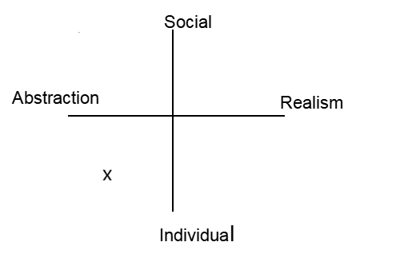
Player sound

X
1 5

Magic Bullet Analysis
Must Learn
Psychomotor | Cognitive | Affective
Basic jump/dive/dash, hat switching (Sprint/Umbrella/Brewing) | Platform navigation, collectible paths, boss patterns | Enjoy cute aesthetic, persist through deaths
Can Learn
Psychomotor | Cognitive | Affective
Advanced combos (dive-jump, wall-run), speed techs | 100% secrets, puzzle optimization, modding basics | Mastery satisfaction, community sharing
External Learning
Psychomotor | Cognitive | Affective
Controller/keyboard proficiency | 3D spatial reasoning (prior platformers) | Genre nostalgia (Mario 64/Banjo)
Coincidental Learning
Psychomotor | Cognitive | Affective
Precise timing/muscle memory | Route planning, physics intuition (trajectories) | Creativity via Workshop mods
Bullet Sketch

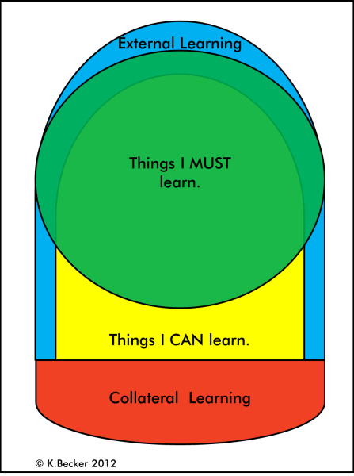

Other Notes:
“A Hat in Time” is a 3D platformer where Hat Kid collects Time Pieces by solving problems by swapping hats (Sprint, Brewing, Time Stop, etc.). The game's main educational strength lies in its training of spatial reasoning and the transition from consumption to content creation via Steam Workshop. Spatial reasoning develops at each level: the player estimates jumping distances, anticipates trajectories, remembers the locations of platforms and checkpoints, and visualizes the interaction of hats with the environment. This requires mental rotation of objects, 3D orientation, and route planning—skills critical for mathematics and physics. Newcombe et al. (2023) demonstrated in a RCT with 287 fourth-grade students that 8 weeks of training in 3D platformers increased spatial reasoning by 20–30%. Tests (Mental Rotation, Paper Folding) and ANOVA confirmed a link with success in geometry and coordinates. “A Hat in Time” is a perfect fit: double jumps, dashes, and Time Stop train the same mechanisms. Creativity is unleashed through Steam Workshop: creating levels, hats, objects, and animations in Unreal Engine 4 teaches 3D modeling, texturing, scripting, and iterative design. Every failure (an impassable level, a bug) is an opportunity to improve, fostering a "fail fast, learn fast" culture. Rodríguez-Valverde et al. (2022), in an analysis of 30 commercial games, awarded “A Hat in Time” 8.62/10, noting: "The same video game could include more than one educational value... learning and developing skills" (p. 10). Modding allows for the creation of content relevant to the lesson's topic (scientific puzzles, historical worlds), turning the game into a project-based activity. According to Bloom's taxonomy (Anderson & Krathwohl, 2001), the scope is complete: remembering hats → applying (jumping) → analyzing routes → creating mods. “A Hat in Time” — 4.5/5 edutainment: transforms abstract geometry into a living experience and makes the child a creator, not just a consumer.

